Downloading...
From: https://drive.google.com/uc?id=1VJaDVtDUtKQMmhRAqr3t-fgng899ZdRV
To: /content/Python Application Usage Log Data Set.xlsx
100%|██████████| 1.68M/1.68M [00:00<00:00, 104MB/s]
Epoch 1/300
19/19 ━━━━━━━━━━━━━━━━━━━━ 12s 138ms/step - loss: 0.4971 - val_loss: 0.2977 - learning_rate: 0.0010
Epoch 2/300
19/19 ━━━━━━━━━━━━━━━━━━━━ 2s 88ms/step - loss: 0.3009 - val_loss: 0.3132 - learning_rate: 0.0010
Epoch 3/300
19/19 ━━━━━━━━━━━━━━━━━━━━ 2s 110ms/step - loss: 0.2938 - val_loss: 0.2594 - learning_rate: 0.0010
Epoch 4/300
19/19 ━━━━━━━━━━━━━━━━━━━━ 2s 82ms/step - loss: 0.2333 - val_loss: 0.2714 - learning_rate: 0.0010
Epoch 5/300
19/19 ━━━━━━━━━━━━━━━━━━━━ 1s 56ms/step - loss: 0.2447 - val_loss: 0.2562 - learning_rate: 0.0010
Epoch 6/300
19/19 ━━━━━━━━━━━━━━━━━━━━ 1s 55ms/step - loss: 0.2214 - val_loss: 0.3067 - learning_rate: 0.0010
Epoch 7/300
19/19 ━━━━━━━━━━━━━━━━━━━━ 1s 60ms/step - loss: 0.2348 - val_loss: 0.2492 - learning_rate: 0.0010
Epoch 8/300
19/19 ━━━━━━━━━━━━━━━━━━━━ 1s 61ms/step - loss: 0.2268 - val_loss: 0.2681 - learning_rate: 0.0010
Epoch 9/300
19/19 ━━━━━━━━━━━━━━━━━━━━ 1s 71ms/step - loss: 0.2451 - val_loss: 0.2296 - learning_rate: 0.0010
Epoch 10/300
19/19 ━━━━━━━━━━━━━━━━━━━━ 2s 83ms/step - loss: 0.2396 - val_loss: 0.3000 - learning_rate: 0.0010
Epoch 11/300
19/19 ━━━━━━━━━━━━━━━━━━━━ 2s 105ms/step - loss: 0.2427 - val_loss: 0.2628 - learning_rate: 0.0010
Epoch 12/300
19/19 ━━━━━━━━━━━━━━━━━━━━ 1s 66ms/step - loss: 0.2200 - val_loss: 0.2691 - learning_rate: 0.0010
Epoch 13/300
19/19 ━━━━━━━━━━━━━━━━━━━━ 1s 52ms/step - loss: 0.2072 - val_loss: 0.2363 - learning_rate: 0.0010
Epoch 14/300
19/19 ━━━━━━━━━━━━━━━━━━━━ 1s 60ms/step - loss: 0.1896 - val_loss: 0.2530 - learning_rate: 0.0010
Epoch 15/300
19/19 ━━━━━━━━━━━━━━━━━━━━ 0s 28ms/step - loss: 0.2049
Epoch 15: ReduceLROnPlateau reducing learning rate to 0.0005000000237487257.
19/19 ━━━━━━━━━━━━━━━━━━━━ 1s 32ms/step - loss: 0.2044 - val_loss: 0.2746 - learning_rate: 0.0010
Epoch 16/300
19/19 ━━━━━━━━━━━━━━━━━━━━ 1s 30ms/step - loss: 0.1970 - val_loss: 0.2890 - learning_rate: 5.0000e-04
Epoch 17/300
19/19 ━━━━━━━━━━━━━━━━━━━━ 1s 32ms/step - loss: 0.1928 - val_loss: 0.3169 - learning_rate: 5.0000e-04
Epoch 18/300
19/19 ━━━━━━━━━━━━━━━━━━━━ 1s 31ms/step - loss: 0.1819 - val_loss: 0.2739 - learning_rate: 5.0000e-04
Epoch 19/300
19/19 ━━━━━━━━━━━━━━━━━━━━ 1s 30ms/step - loss: 0.1994 - val_loss: 0.2914 - learning_rate: 5.0000e-04
Epoch 20/300
19/19 ━━━━━━━━━━━━━━━━━━━━ 1s 31ms/step - loss: 0.1770 - val_loss: 0.2836 - learning_rate: 5.0000e-04
Epoch 21/300
17/19 ━━━━━━━━━━━━━━━━━━━━ 0s 26ms/step - loss: 0.2135
Epoch 21: ReduceLROnPlateau reducing learning rate to 0.0002500000118743628.
19/19 ━━━━━━━━━━━━━━━━━━━━ 1s 30ms/step - loss: 0.2111 - val_loss: 0.2890 - learning_rate: 5.0000e-04
Epoch 22/300
19/19 ━━━━━━━━━━━━━━━━━━━━ 1s 32ms/step - loss: 0.2087 - val_loss: 0.2844 - learning_rate: 2.5000e-04
Epoch 23/300
19/19 ━━━━━━━━━━━━━━━━━━━━ 1s 31ms/step - loss: 0.2183 - val_loss: 0.2671 - learning_rate: 2.5000e-04
Epoch 24/300
19/19 ━━━━━━━━━━━━━━━━━━━━ 1s 30ms/step - loss: 0.1779 - val_loss: 0.2714 - learning_rate: 2.5000e-04

VAL — MAE: 367.24 | RMSE: 489.73 | MAPE: 37.43%

VAL (accuracy-optimized) — thr: 499.056 | Acc: 96.15% | F1: 0.98 | P: 0.96 | R: 1.00
Confusion matrix [TN FP; FN TP]:
[[ 0 1]
[ 0 25]]
Epoch 1/23
20/20 ━━━━━━━━━━━━━━━━━━━━ 4s 23ms/step - loss: 0.4062
Epoch 2/23
20/20 ━━━━━━━━━━━━━━━━━━━━ 0s 21ms/step - loss: 0.3488
Epoch 3/23
20/20 ━━━━━━━━━━━━━━━━━━━━ 0s 21ms/step - loss: 0.2363
Epoch 4/23
20/20 ━━━━━━━━━━━━━━━━━━━━ 1s 22ms/step - loss: 0.2689
Epoch 5/23
20/20 ━━━━━━━━━━━━━━━━━━━━ 0s 22ms/step - loss: 0.2143
Epoch 6/23
20/20 ━━━━━━━━━━━━━━━━━━━━ 0s 22ms/step - loss: 0.2335
Epoch 7/23
20/20 ━━━━━━━━━━━━━━━━━━━━ 0s 22ms/step - loss: 0.2172
Epoch 8/23
20/20 ━━━━━━━━━━━━━━━━━━━━ 1s 21ms/step - loss: 0.2348
Epoch 9/23
20/20 ━━━━━━━━━━━━━━━━━━━━ 0s 21ms/step - loss: 0.1914
Epoch 10/23
20/20 ━━━━━━━━━━━━━━━━━━━━ 0s 21ms/step - loss: 0.1822
Epoch 11/23
20/20 ━━━━━━━━━━━━━━━━━━━━ 1s 22ms/step - loss: 0.2113
Epoch 12/23
20/20 ━━━━━━━━━━━━━━━━━━━━ 0s 21ms/step - loss: 0.2115
Epoch 13/23
20/20 ━━━━━━━━━━━━━━━━━━━━ 0s 21ms/step - loss: 0.1971
Epoch 14/23
20/20 ━━━━━━━━━━━━━━━━━━━━ 0s 23ms/step - loss: 0.1958
Epoch 15/23
20/20 ━━━━━━━━━━━━━━━━━━━━ 0s 21ms/step - loss: 0.1915
Epoch 16/23
20/20 ━━━━━━━━━━━━━━━━━━━━ 1s 24ms/step - loss: 0.1921
Epoch 17/23
20/20 ━━━━━━━━━━━━━━━━━━━━ 1s 36ms/step - loss: 0.2035
Epoch 18/23
20/20 ━━━━━━━━━━━━━━━━━━━━ 1s 36ms/step - loss: 0.1881
Epoch 19/23
20/20 ━━━━━━━━━━━━━━━━━━━━ 1s 29ms/step - loss: 0.2049
Epoch 20/23
20/20 ━━━━━━━━━━━━━━━━━━━━ 0s 22ms/step - loss: 0.1846
Epoch 21/23
20/20 ━━━━━━━━━━━━━━━━━━━━ 1s 22ms/step - loss: 0.1674
Epoch 22/23
20/20 ━━━━━━━━━━━━━━━━━━━━ 0s 22ms/step - loss: 0.2114
Epoch 23/23
20/20 ━━━━━━━━━━━━━━━━━━━━ 1s 22ms/step - loss: 0.1818
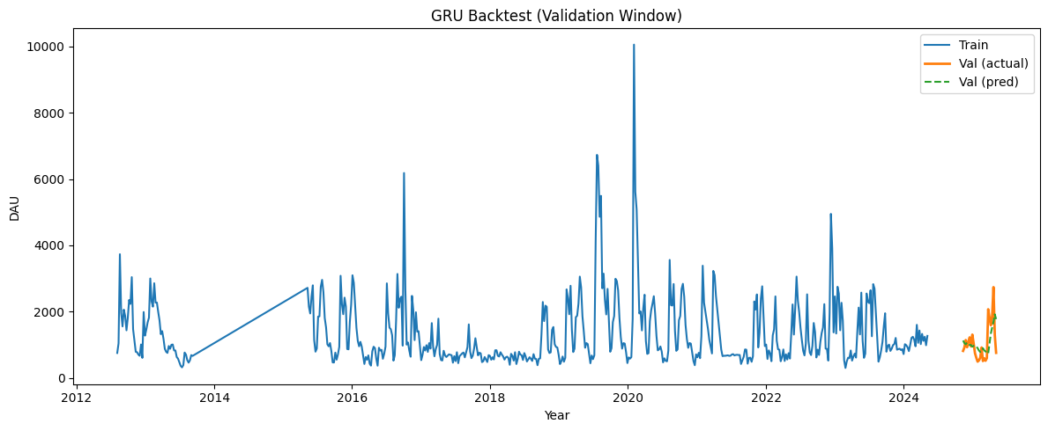
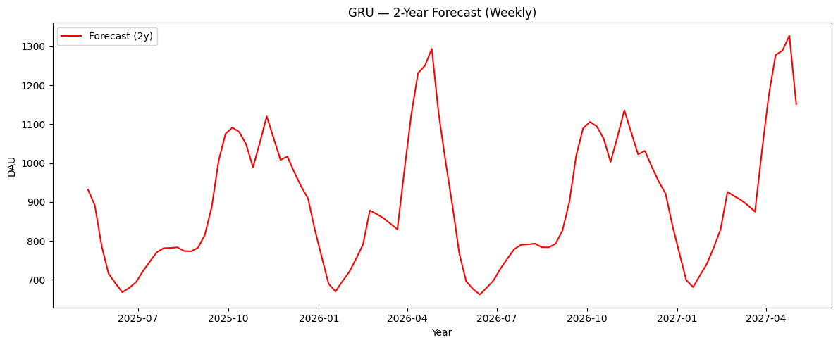
▶ Validation (fixed TRAIN-median threshold)
Threshold: 1003.513
Accuracy : 69.23%
F1 Score : 0.64
Precision: 0.64
Recall : 0.64
Confusion matrix [TN FP; FN TP]:
[[11 4]
[ 4 7]]

▶ Validation (accuracy-optimized threshold)
Threshold: 499.056
Accuracy : 96.15%
F1 Score : 0.98
Precision: 0.96
Recall : 1.00
Confusion matrix [TN FP; FN TP]:
[[ 0 1]
[ 0 25]]

